**Experiment-3**

**Aim: Docker Network**

Step-1: Create a network

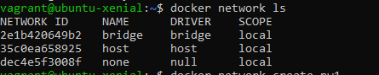

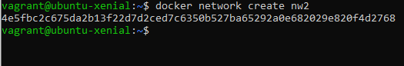

Step-2: Create a container and assign the created network to container.



Step-3: Use docker ps to check the running containers.

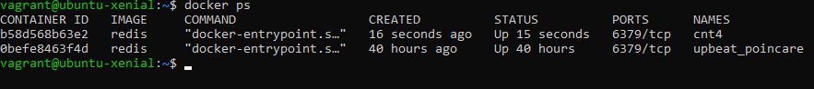

Step-4: Create another container on same network and verify the connectivity using ping command.

